This will require previous version

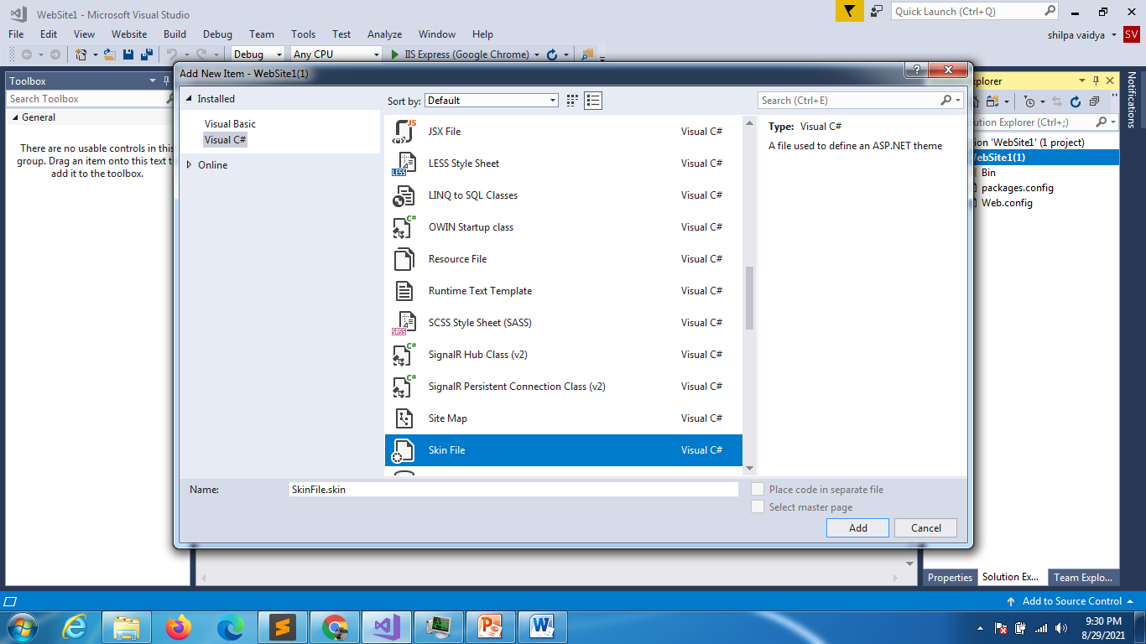

Say yes to next dialogue box

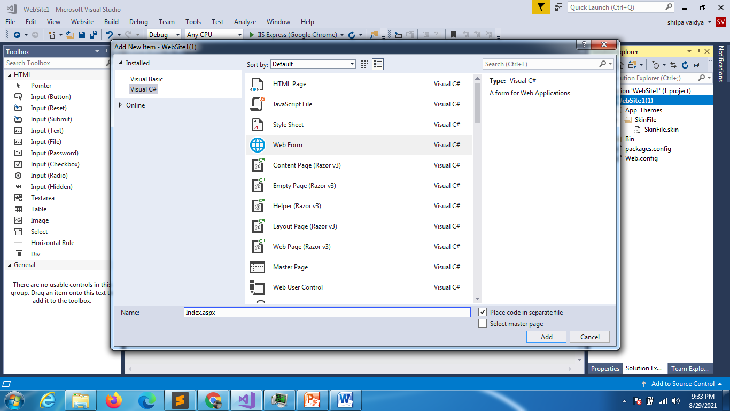

<%@ Page Language="C#" AutoEventWireup="true" CodeFile="Index.aspx.cs" Inherits="Index" StylesheetTheme ="SkinFile"%>

<!DOCTYPE html>

<html xmlns="http://www.w3.org/1999/xhtml">

<head runat="server">

    <title></title>

</head>

<body>

    <form id="form1" runat="server">

        <div>

        </div>

    </form>

</body>

</html>

Add button to the file

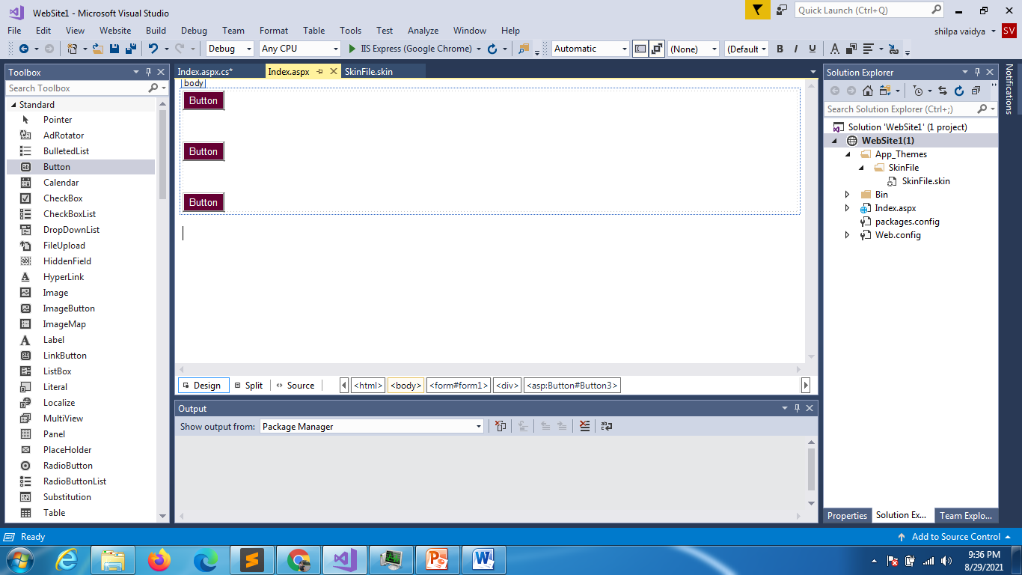

But all buttons are taking same color that is the last button properties that we have added to the file.

Add the skin ids

<asp:Button SkinId="darkblue"   runat="server" BackColor="#000099" ForeColor="White" Text="Button" />

<asp:Button SkinId="orange"   runat="server" BackColor="#FF6600" ForeColor="White" Text="Button" />

<asp:Button SkinId="brown"   runat="server" BackColor="#660033" ForeColor="White" Text="Button" />

